Your name \_\_\_\_\_\_\_\_\_\_\_\_\_\_\_\_\_\_\_\_\_\_\_\_\_\_\_\_\_\_\_\_\_\_\_\_\_\_\_\_\_ Date \_\_\_\_\_\_\_\_\_\_\_\_\_\_\_\_

**Good luck!**

**Introduction to the project:**

|  |  |
| --- | --- |
| Imagine that you are assigned to a new project as a tester.  Testing team: you and test team lead Mike.  This is a small mobile project for iOS.  “Canteen menu” application is developed for a huge company located all over the world. Application is targeted on company’s canteens stuff. It will be used for week menu management (creation, edition, etc).  Canteen employees are equipped with iPads or iPhones XR.  After login to the application user (canteen employee) is redirected to “Menu List” screen with the list of menus for different company’s canteens (in different locations), “Country”, “City”, “Canteen” filters.  **New feature “Menu Editor” will be implemented during the upcoming iteration.**  Your task is:   1. Review the requirements for the new feature provided by BA Barbara 2. In case of any questions you have to write email to Barbara with request to clarify your questions 3. Provide estimations for test activities for this feature by email to your test lead Mike 4. Write test cases for the feature 5. Review provided screens with the implemented feature 6. Find and submit bugs in case of any 7. Send test results and your decision about quality of the feature to Mike   **Below you will find requirements for the feature and templates for emails, test cases, bug reports, etc. Please fill in only those templates that you think reasonable in scope of this feature. You can write any additional information if required.** | E:\lectures\Test 3\1.png |
| **Requirements for the new feature:**  AS an administrator  I CAN **create menu**:   1. I am in “Menu List” screen 2. I click “create” button - “Menu Editor” screen opens 3. I type canteen name in “Menu name” field 4. I choose canteen from list and click it 5. I select “To” date from date picker 6. I select “From” date from date picker 7. I click “save” button – “Menu List” screen opens, new menu is added to the list | E:\lectures\Test 3\2crop.png |
| AS an administrator  I CAN **edit menu**:   1. I am in “Menu List” screen 2. I click edit icon C:\Users\Lidziya_Smirnova\Desktop\Icons\89031-200.png - “Menu Editor” screen opens 3. From the dates panel I choose date I want to add dish offers to 4. In dish categories list I choose category I want to add dish offers to 5. If there are no dishes in the category – empty field is displayed 6. If the number of dishes exceeds the screen – the list can be scrolled 7. I can remove dish from the list 8. “Add dish” feature will be implemented later | |
| E:\lectures\Test 3\2.png | E:\lectures\Test 3\2a.png |

**Clarification letter to BA regarding new feature:**

|  |  |
| --- | --- |
| **To:** | Barbara Smith |
| **CC:** |  |
| **Subject:** |  |
|  | |

**Test estimations for new feature to Test team lead:**

|  |  |
| --- | --- |
| **To:** | Mike |
| **CC:** |  |
| **Subject:** |  |
|  | |

**Test cases for new feature:**

|  |  |  |  |  |  |  |
| --- | --- | --- | --- | --- | --- | --- |
| **№** |  |  |  |  |  |  |
|  |  |  |  |  |  |  |
| **№** |  |  |  |  |  |  |
|  |  |  |  |  |  |  |
| **№** |  |  |  |  |  |  |
|  |  |  |  |  |  |  |
| **№** |  |  |  |  |  |  |
|  |  |  |  |  |  |  |

**“Menu Editor” feature is ready for testing:**

Developers have finished implementation of “Menu Editor” feature. Build with the feature is released and successfully installed.

When editing the menu you see the following screen:

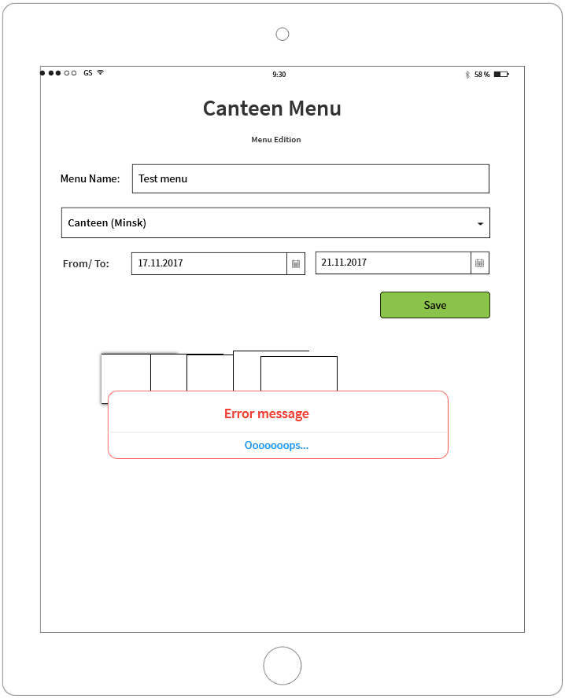

**If you see any bugs in this screen, you can post them below:**

**Bug reports:**

|  |  |
| --- | --- |
| **Bug ID** | **#1** |
|  |  |
|  |  |
|  |  |
|  |  |
| **Bug ID** | **#2** |
|  |  |
|  |  |
|  |  |
|  |  |
| **Bug ID** | **#3** |
|  |  |
|  |  |
|  |  |
|  |  |